**HUBBLEMIND SQL Internship**

SQL Project Report: Border_Crossing_Entry_Data

SQL Tasks – Solutions

Date: 5-11-2024

**________________________________________________________________________________**

**Project Description:** Analysis of border crossing data between the U.S.-Canada and U.S.-Mexico borders. It will engage in tasks that involve data exploration, aggregations, and advanced SQL queries, simulating real-world data analysis scenarios

**Data source:** [Dataset](https://drive.google.com/file/d/1zlihebregjf7S-TmIr2zE-FMXtaPyAb9/view?usp=sharing)

**Database Environment:** MySQL WorkBench

**Analysis Techniques:** SQL queries

First created a SCHEMA named Cross_Border_Crisis then created TABLE named Border_Crossing_Entry_Data with columns given in the dataset.

-- creating schema and table

**CREATE DATABASE IF NOT EXISTS** cross_border_crisis;

**USE** cross_border_crisis;

**CREATE TABLE** border_crossing_entry_data(

Port_Name VARCHAR(50),

State VARCHAR(50),

Port_Code int,

Border VARCHAR(50),

Date CHAR(10),

Measure VARCHAR(50),

Value int

);

**SELECT** \***FROM** border_crossing_entry_data;

-- Then imported data by selecting Data Import Wizard in Server menu

**SELECT** * **FROM** border_crossing_entry_data;

**OUTPUT:**

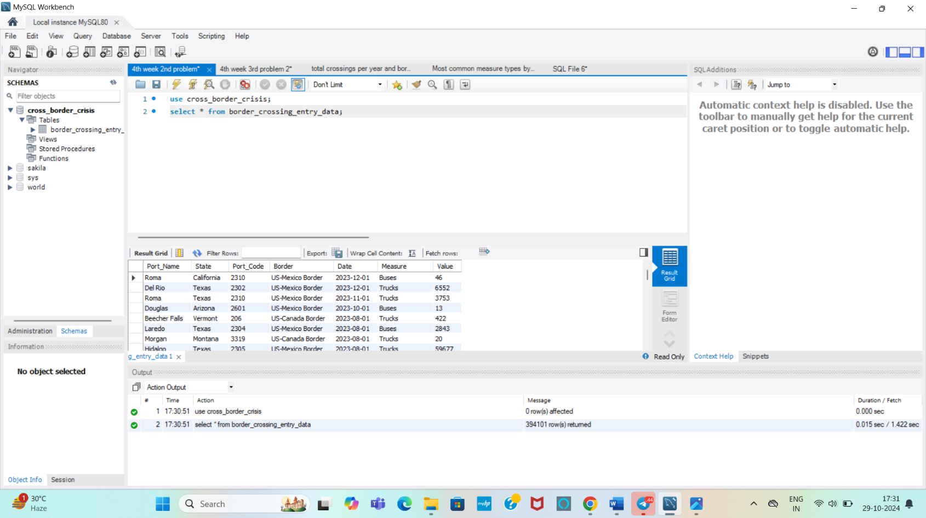

**- - - - - - - - - - - - - - - - - - - - - - - - - - - - - - - - - - - - - - - - - - - - - - - - - - - - - - - - - - - - - - - - - - - - - - - - - - - - - - - - - -**

**Week 1: Data Exploration and Basic Queries**

**1. List all distinct port names and their corresponding states.**

Here is an SQL query to list all distinct port names and their corresponding states from the Border Crossing table:

**QUERY:**

**SELECT DISTINCT** port_name, state **FROM** border_crossing_entry_data;

**OUTPUT:**

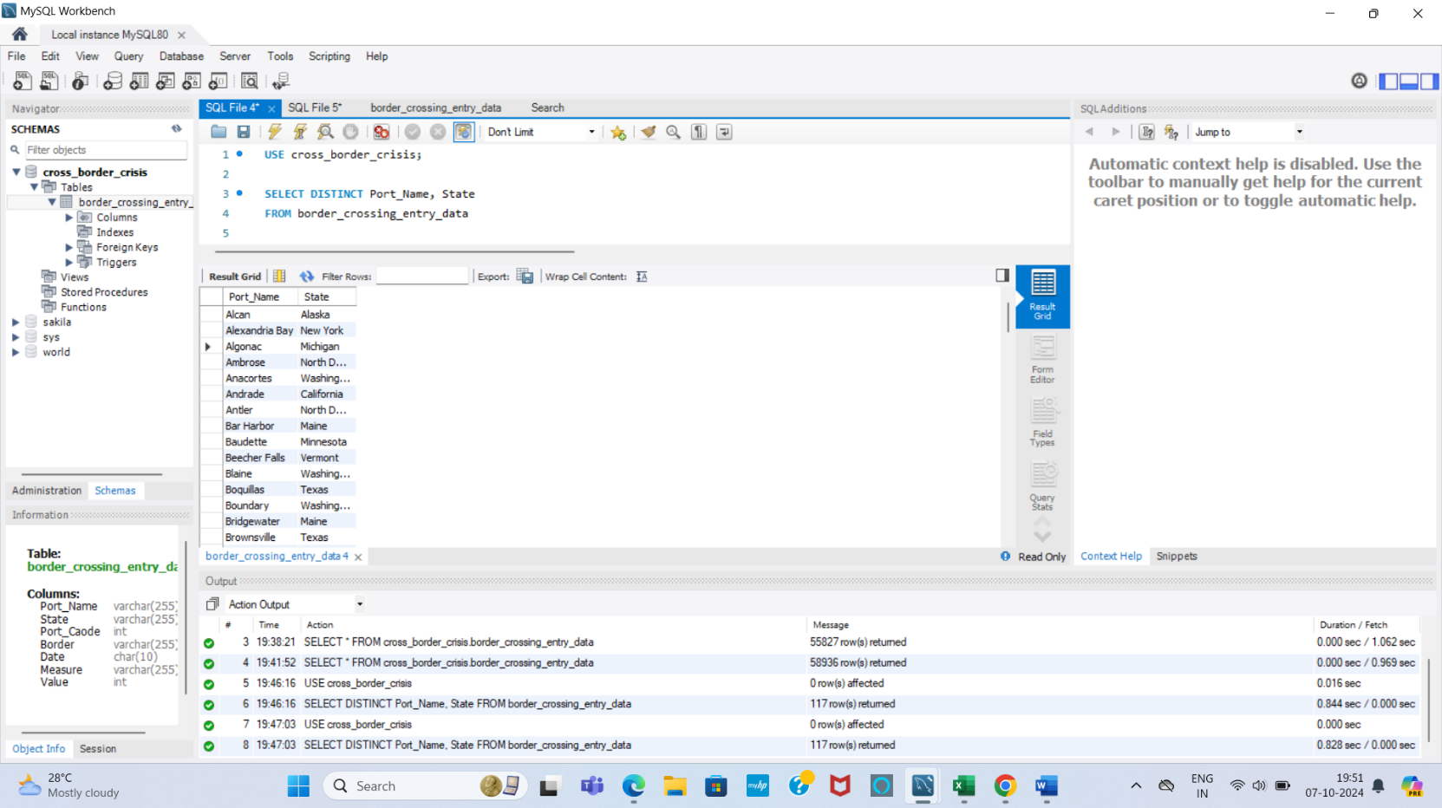

**DESCRIPTION:**

1. SELECT DISTINCT: Ensures that the results contain only unique combinations of port names and states.
2. port_name, state: Specifies the columns to be included in the output.

**- - - - - - - - - - - - - - - - - - - - - - - - - - - - - - - - - - - - - - - - - - - - - - - - - - - - - - - - - - - - - - - - - - - - - - - - - - - - - - - - - -**

**2. Count the total number of unique Borders and the total number of entries associated with each Border.**

**QUERY:**

**SELECT COUNT**(**DISTINCT** Border) **AS** Total_Unique_Borders, **COUNT**(*) **AS** Total_Entries

**FROM** border_crossing_entry_data

**GROUP BY** Border;

**OUTPUT:**

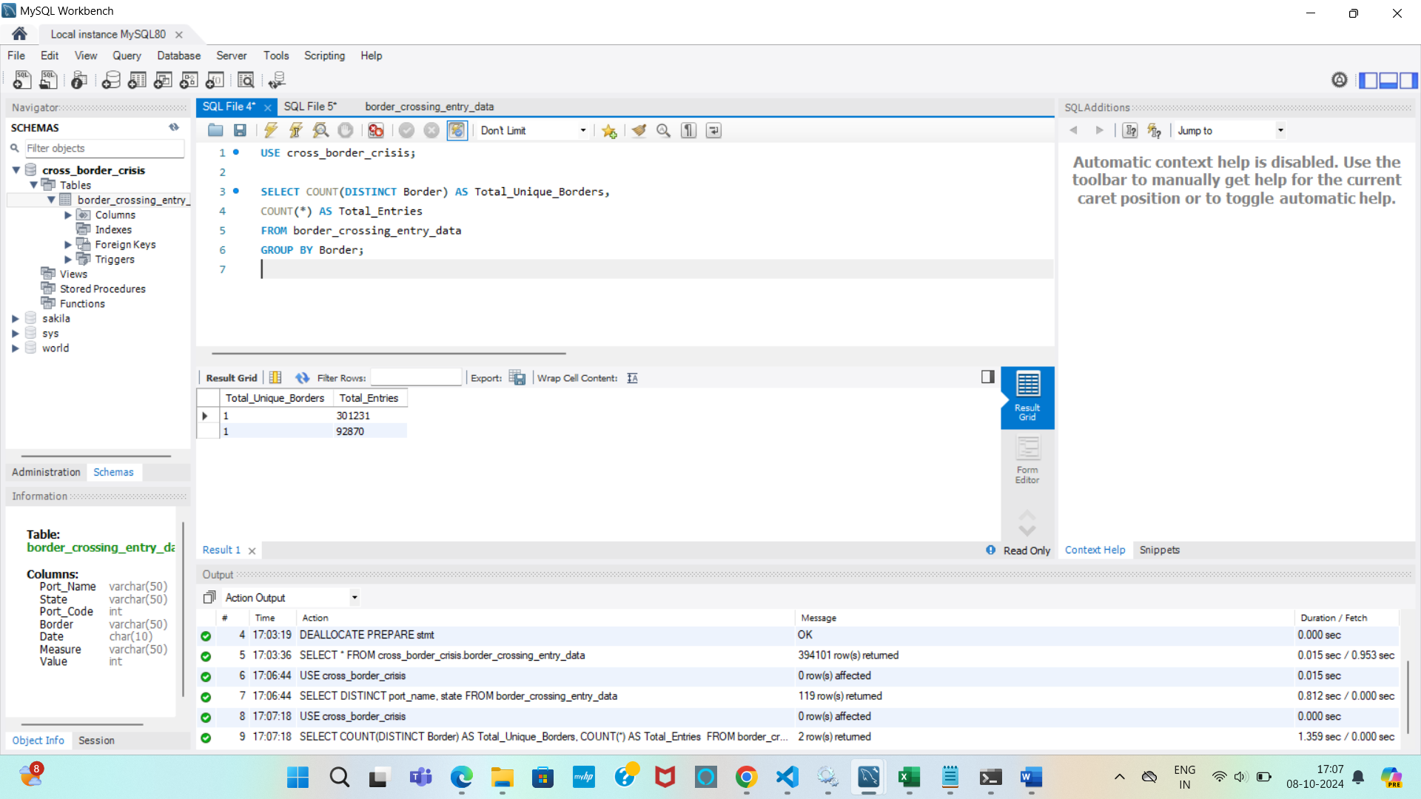

**DESCRIPTION:**

1. COUNT(DISTINCT Border) AS Total_Unique_Borders: Counts the unique borders and labels the result as Total_Unique_Borders.
2. COUNT(*) AS Total_Entries: Counts the total number of entries for each border and labels it as Total_Entries.
3. GROUP BY Border: Groups the results by each border.

**- - - - - - - - - - - - - - - - - - - - - - - - - - - - - - - - - - - - - - - - - - - - - - - - - - - - - - - - - - - - - - - - - - - - - - - - - - - - - - - - - -**

**3. Retrieve the total number of entries (crossings) for each year, sorted from most recent to oldest year.**

**QUERY:**

**SELECT YEAR**(Date) **AS** year, **SUM**(Value) **AS** total_entries **FROM** border_crossing_entry_data

**GROUP BY** YEAR(Date)

**ORDER BY** year **DESC**;

**OUPUT:**

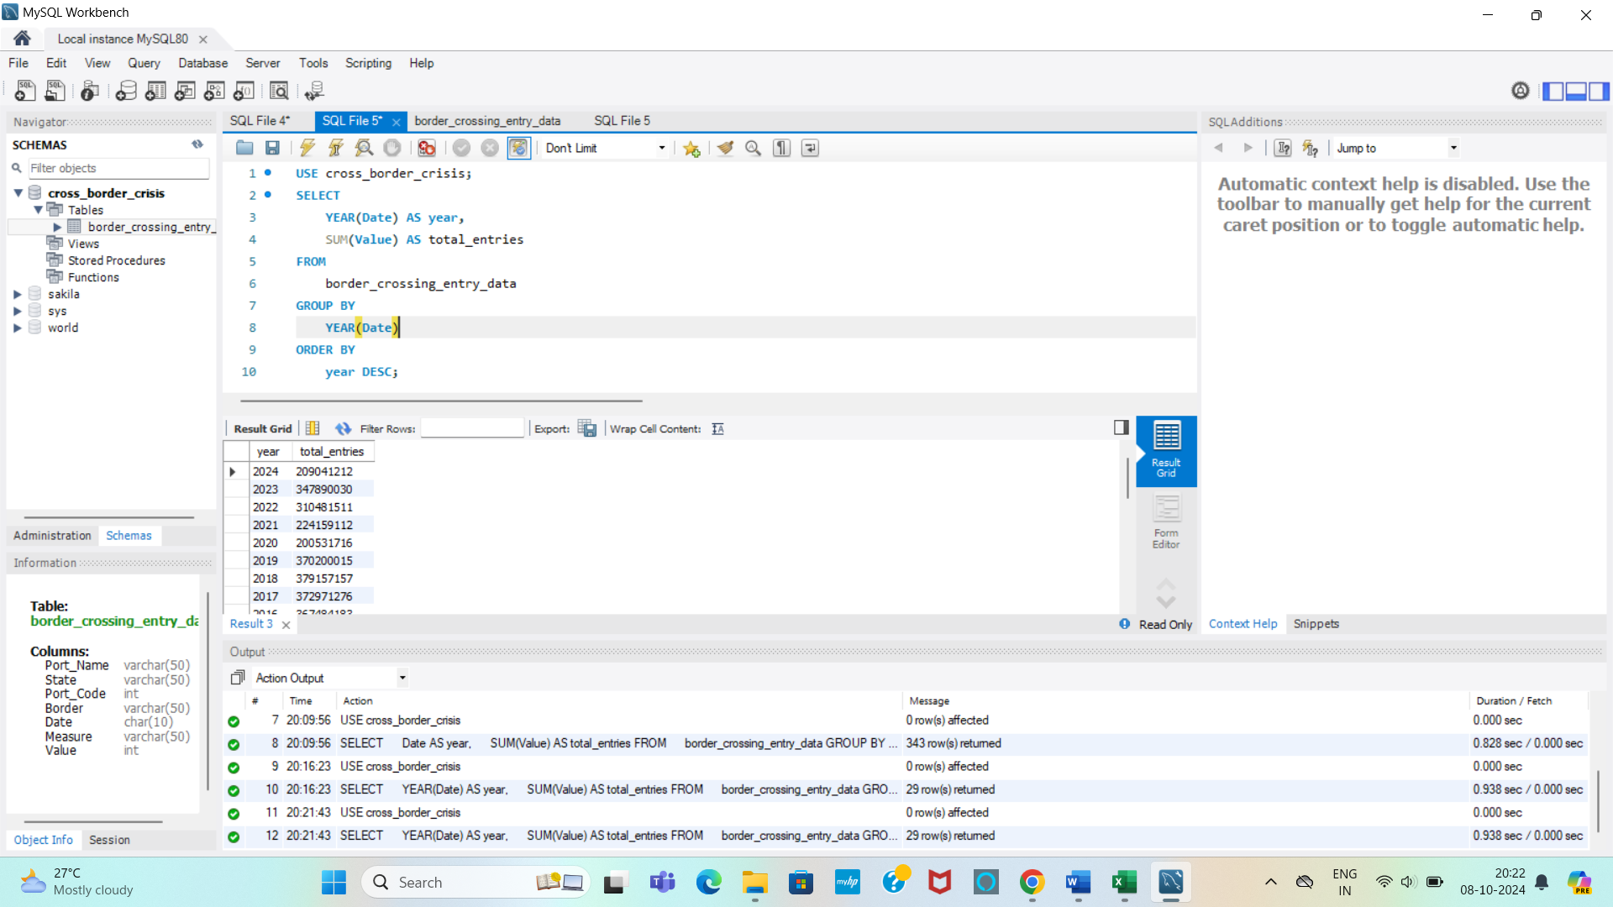

**DESCRIPTION:**

1. SELECT YEAR(Date) AS year: Extracts the year from the Date column and labels it as year.
2. SUM(Value) AS total_entries: Calculates the total number of entries (crossings) for each year and labels the result as total_entries.
3. FROM border_crossing_entry_data: Specifies the table from which to retrieve the data.
4. GROUP BY YEAR(Date): Groups the results by year, allowing the aggregation function SUM() to compute totals for each year.
5. ORDER BY year DESC: Sorts the results in descending order by year, so the most recent year appears first.

**- - - - - - - - - - - - - - - - - - - - - - - - - - - - - - - - - - - - - - - - - - - - - - - - - - - - - - - - - - - - - - - - - - - - - - - - - - - - - - - - - -**

**4. Find all ports that have recorded more than 5000 crossings for the Trucks measure type.**

**QUERY:**

**SELECT** Port_Name **FROM** border_crossing_entry_Data

**WHERE** Measure = 'Trucks'

**GROUP BY** Port_Name

**HAVING SUM**(Value) > 5000;

**OUTPUT:**

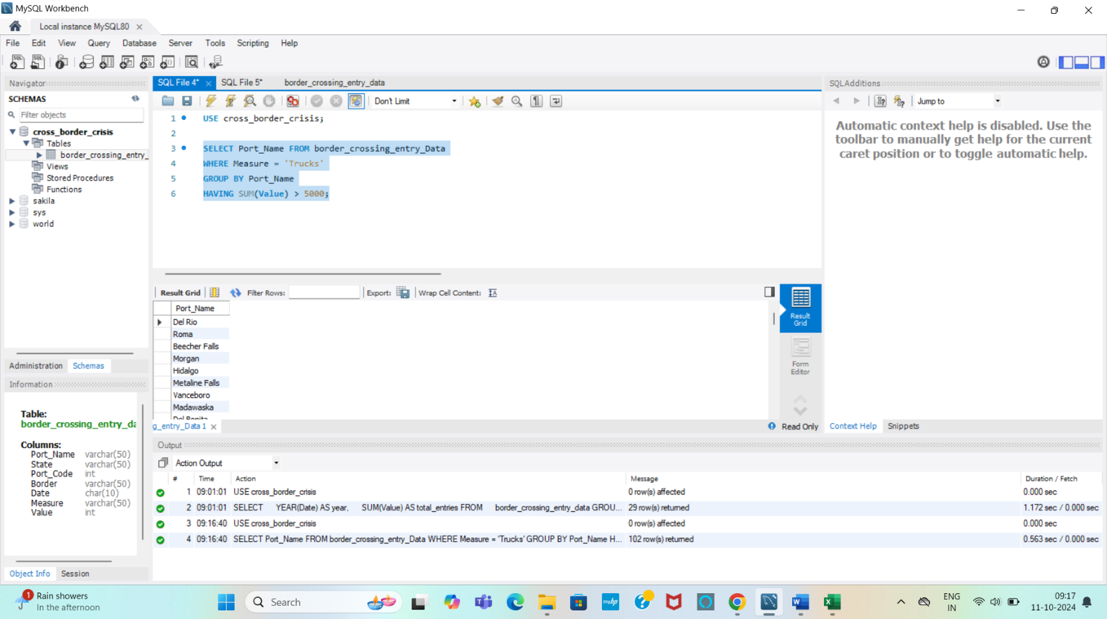

**DESCRIPTION:**

1. WHERE Measure = 'Trucks': Filters the data to include only entries related to truck crossings.
2. GROUP BY Port_Name: Groups the results by port name.
3. HAVING SUM(Value) > 5000: Ensures that only ports with a total of more than 5,000 crossings are included in the results.

**- - - - - - - - - - - - - - - - - - - - - - - - - - - - - - - - - - - - - - - - - - - - - - - - - - - - - - - - - - - - - - - - - - - - - - - - - - - - - - - - - -**

**5. Identify the top 3 states with the highest total number of pedestrian crossings.**

**QUERY:**

**SELECT** State, **SUM**(Value) **AS** total_pedestrian_crossings **FROM** border_crossing_entry_data

**WHERE** Measure = 'Pedestrians'

**GROUP BY** State

**ORDER BY** total_pedestrian_crossings **DESC**

**LIMIT** 3;

**OUTPUT:**

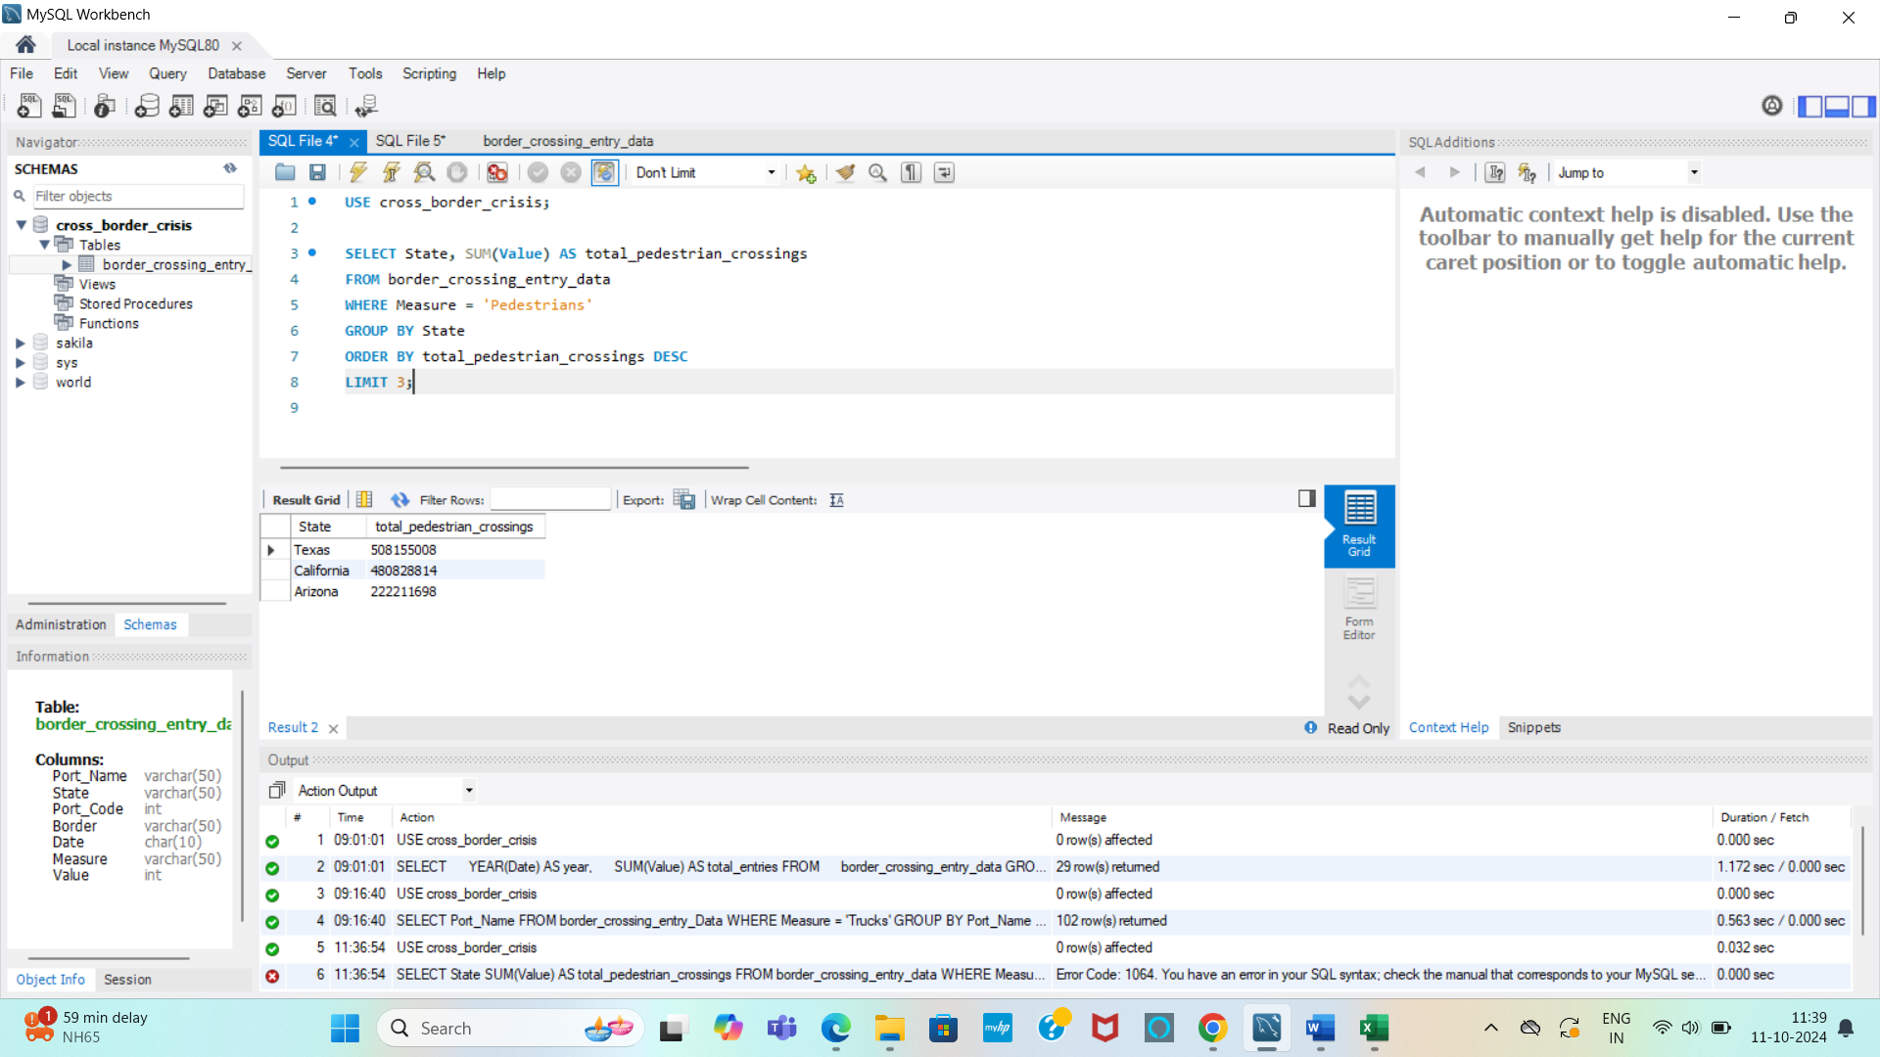

**DESCRIPTION:**

1. WHERE Measure = 'Pedestrians': Filters the data to include only pedestrian crossings.
2. SUM(Value) AS total_pedestrian_crossings: Calculates the total number of pedestrian crossings for each state and labels it as total_pedestrian_crossings.
3. GROUP BY State: Groups the results by state.
4. ORDER BY total_pedestrian_crossings DESC: Sorts the states in descending order based on the total number of crossings.
5. LIMIT 3: Restricts the output to the top three states.

**- - - - - - - - - - - - - - - - - - - - - - - - - - - - - - - - - - - - - - - - - - - - - - - - - - - - - - - - - - - - - - - - - - - - - - - - - - - - - - - - - -**

**6. For the year 2023, extract the total number of crossings per month, categorized by measure type.**

**QUERY:**

**SELECT DATE_FORMAT** (Date, '%Y-%m') **AS** month, Measure, **SUM**(Value) **AS** total_crossings

**FROM** border_crossing_entry_data

**WHERE** YEAR(Date) = 2023

**GROUP BY** month, Measure

**ORDER BY** month, Measure;

**OUTPUT:**

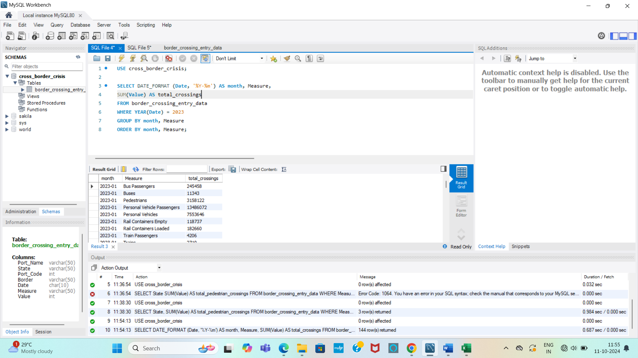

**DESCRIPTION:**

1. DATE_FORMAT(Date, '%Y-%m') AS month: Formats the Date column to show the year and month and labels it as month.
2. Measure: Includes the type of measure (e.g., Trucks, Pedestrians).
3. SUM(Value) AS total_crossings: Calculates the total number of crossings for each measure and month, labeling it as total_crossings.
4. WHERE YEAR(Date) = 2023: Filters the data to include only entries from the year 2023.
5. GROUP BY month, Measure: Groups the results by formatted month and measure type.
6. ORDER BY month, Measure: Sorts the results first by month and then by measure type

**- - - - - - - - - - - - - - - - - - - - - - - - - - - - - - - - - - - - - - - - - - - - - - - - - - - - - - - - - - - - - - - - - - - - - - - - - - - - - - - - - -**

7. **Find which measure type is the most frequently recorded for each state.**

**QUERY:**

**SELECT** State, Measure, **COUNT**(*) **AS** Frequency

**FROM** border_crossing_entry_data

**GROUP BY** State, Measure

**HAVING COUNT**(*) = (

**SELECT MAX**(sub_count)

**FROM** (

**SELECT** State, Measure, **COUNT**(*) **AS** sub_count

**FROM** border_crossing_entry_data

**GROUP BY** State, Measure

) **AS** subquery

**WHERE** subquery.state = border_crossing_entry_data.state

)

**ORDER BY** State;

**OUTPUT:**

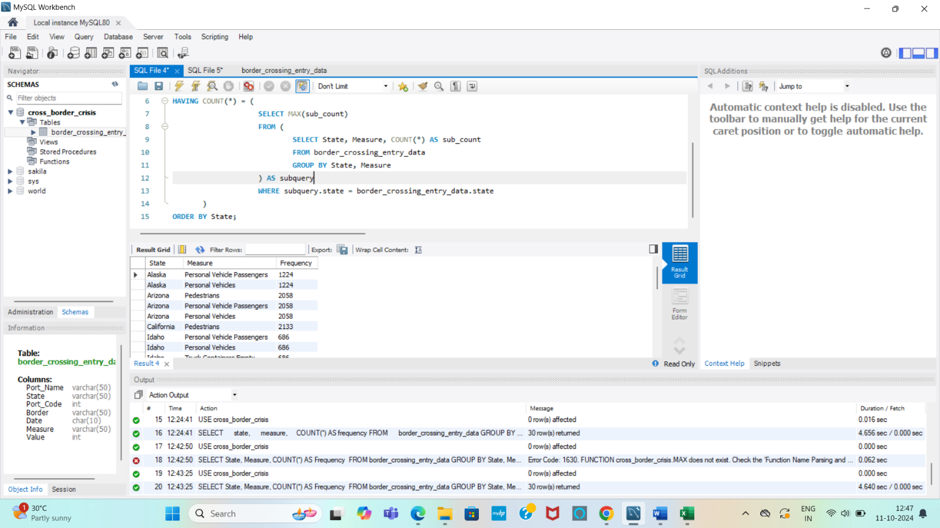

**DESCRIPTION:**

1. SELECT State, Measure, COUNT(*) AS Frequency: Selects the state and measure type while counting the number of entries for each combination, labeling it as Frequency.
2. GROUP BY State, Measure: Groups the results by state and measure type.
3. HAVING COUNT(*) = (...): Filters the results to only include those combinations where the count matches the maximum count for that specific state.
4. The subquery calculates the maximum count of entries (MAX(sub_count)) for each state and measure combination.
5. ORDER BY State: Sorts the results alphabetically by state.

**- - - - - - - - - - - - - - - - - - - - - - - - - - - - - - - - - - - - - - - - - - - - - - - - - - - - - - - - - - - - - - - - - - - - - - - - - - - - - - - - - -**

**8. Generate a summary report showing the total number of crossings for each measure type, grouped by border.**

**QUERY:**

**SELECT** Border, Measure, **SUM**(Value) **AS** total_crossings **FROM** border_crossing_entry_data

**GROUP BY** Border, Measure

**ORDER BY** Border, total_crossings **DESC**;

**OUTPUT:**

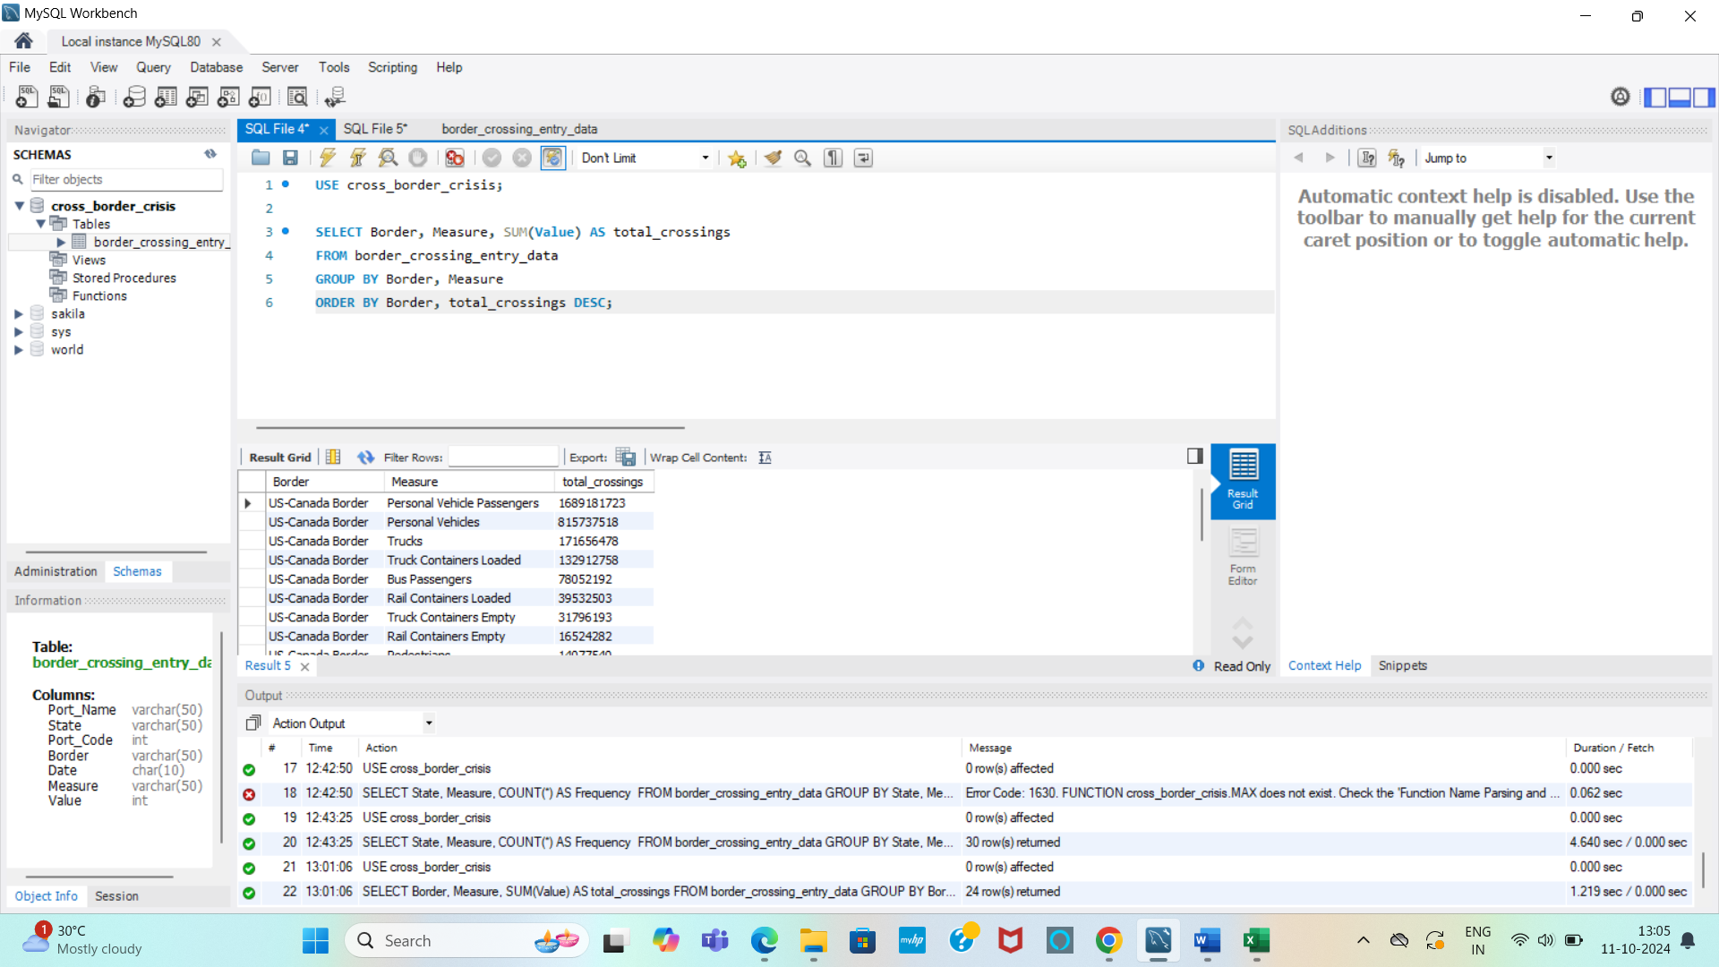

**DESCRIPTION:**

1. SELECT Border, Measure, SUM(Value) AS total_crossings: Selects the border and measure type while summing the number of crossings, labeling the result as total_crossings.
2. GROUP BY Border, Measure: Groups the results by border and measure type.
3. ORDER BY Border, total_crossings DESC: Sorts the results first by border (alphabetically) and then by the total number of crossings in descending order.

**- - - - - - - - - - - - - - - - - - - - - - - - - - - - - - - - - - - - - - - - - - - - - - - - - - - - - - - - - - - - - - - - - - - - - - - - - - - - - - - - - -**

**Week 2: Intermediate Queries with Aggregations**

**1. For Texas, calculate the average number of crossings per month for each measure type**.

**QUERY:**

**SELECT** Measure, **AVG**(Value) **AS** average_crossings_per_month **FROM** border_crossing_entry_data

**WHERE** State = 'Texas'

**GROUP BY** Measure;

**OUTPUT:**

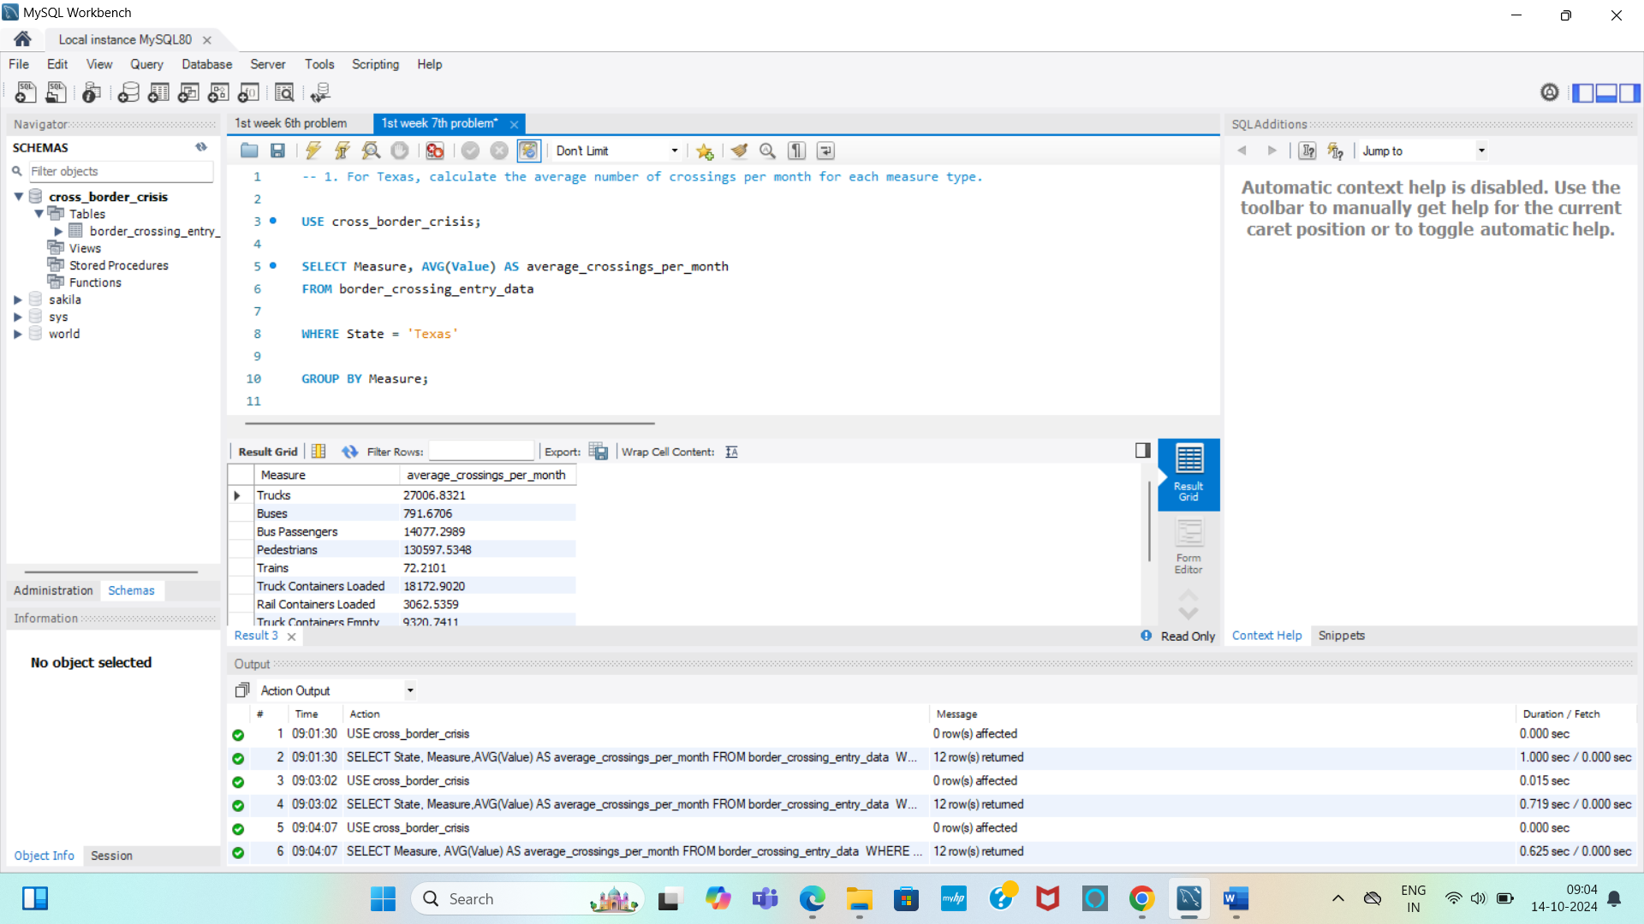

**DESCRIPTION:**

1. SELECT Measure, AVG(Value) AS average_crossings_per_month: Selects the measure type and computes the average crossings, labeling it as average_crossings_per_month.
2. WHERE State = 'Texas': Filters the data to include only entries related to Texas.
3. GROUP BY Measure: Groups the results by measure type.

**- - - - - - - - - - - - - - - - - - - - - - - - - - - - - - - - - - - - - - - - - - - - - - - - - - - - - - - - - - - - - - - - - - - - - - - - - - - - - - - - - -**

**2. Find the port on the U.S.-Canada border with the highest number of crossings. Include the measure type and total crossings.**

**QUERY:**

**SELECT** Port_Name, Measure, **SUM**(Value) **AS** total_crossings **FROM** border_crossing_entry_data

**WHERE** Border = 'US-Canada border'

**GROUP BY** Port_Name, Measure

**ORDER BY** total_crossings DESC

**LIMIT** 1;

**OUTPUT:**

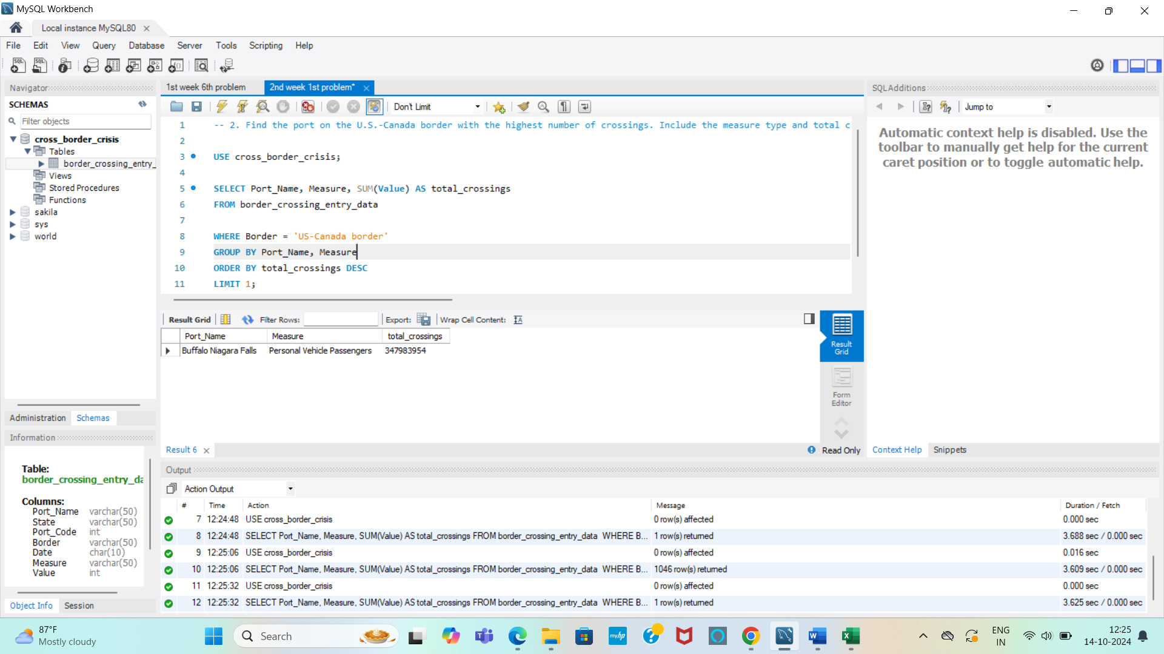

**DESCRIPTION:**

1. SELECT Port_Name, Measure, SUM(Value) AS total_crossings: Selects the port name and measure type while calculating the total number of crossings, labeling it as total_crossings.
2. WHERE Border = 'US-Canada border': Filters the data to include only entries for the U.S.-Canada border.
3. GROUP BY Port_Name, Measure: Groups the results by port name and measure type.
4. ORDER BY total_crossings DESC: Sorts the results in descending order based on the total crossings.
5. LIMIT 1: Restricts the output to the port with the highest total crossings.

**- - - - - - - - - - - - - - - - - - - - - - - - - - - - - - - - - - - - - - - - - - - - - - - - - - - - - - - - - - - - - - - - - - - - - - - - - - - - - - - - -**

**3. Calculate the total number of crossings for the "Buses" measure type in each state, ordered by total crossings in descending order.**

**QUERY:**

**SELECT** State, **SUM(**Value) **AS** total_bus_crossings **FROM** border_crossing_entry_data

**WHERE** Measure = 'Buses'

**GROUP BY** State

**ORDER BY** total_bus_crossings **DESC**;

**OUTPUT:**

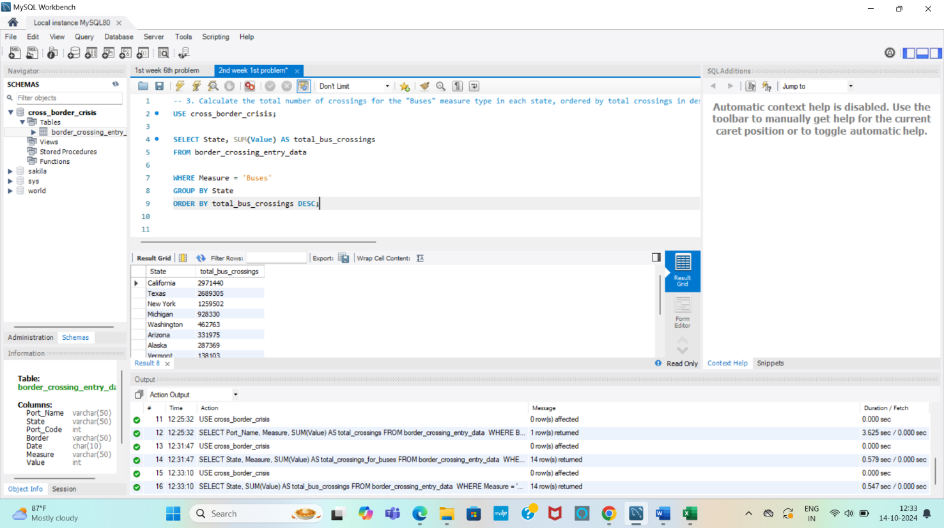

**DESCRIPTION:**

1. WHERE Measure = 'Buses': Filters the data to include only bus crossings.
2. SUM(Value): Calculates the total bus crossings for each state.
3. GROUP BY State: Groups the data by state.
4. ORDER BY total_bus_crossings DESC: Sorts the results with the highest totals first.

**- - - - - - - - - - - - - - - - - - - - - - - - - - - - - - - - - - - - - - - - - - - - - - - - - - - - - - - - - - - - - - - - - - - - - - - - - - - - - - - - - -**

**4. For the U.S.-Mexico border, calculate the average and total number of crossings for each port in the year 2022.**

**QUERY:**

**SELECT** Port_Name, **AVG**(Value) **AS** average_crossings, **SUM**(Value) **AS** total_crossings

**FROM** border_crossing_entry_data

**WHERE** Border = 'US-Mexico border' **AND** YEAR(Date) = 2022

**GROUP BY** Port_Name

**ORDER BY** total_crossings **DESC**;

**OUTPUT:**

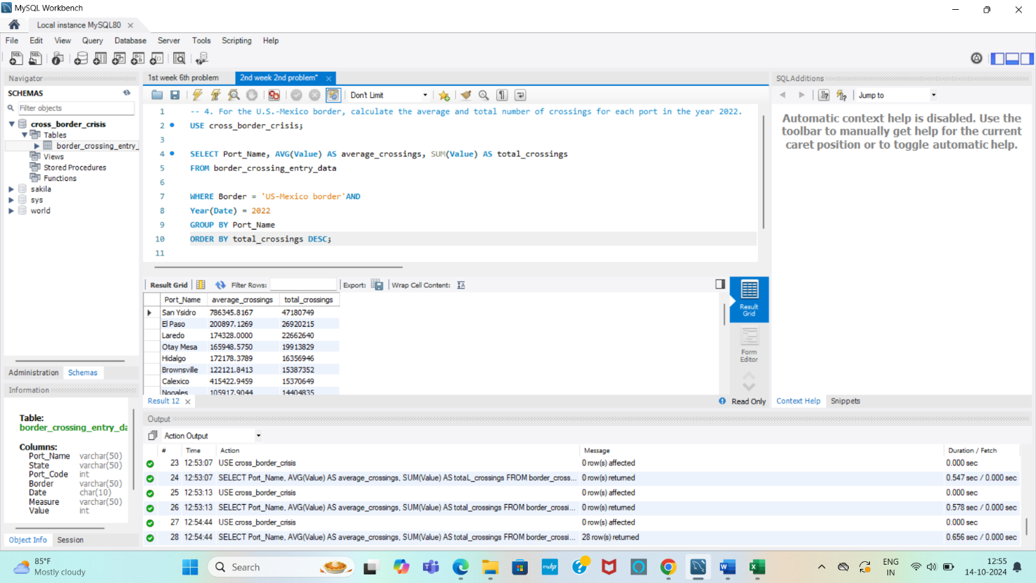

**DESCRIPTION:**

1. WHERE Border = 'US-Mexico border' AND YEAR(Date) = 2022: Filters data for crossings on the U.S.-Mexico border in 2022.
2. AVG(Value): Computes the average number of crossings per port.
3. SUM(Value): Calculates the total number of crossings per port.
4. GROUP BY Port_Name: Groups data by each port.
5. ORDER BY total_crossings DESC: Sorts ports by total crossings in descending order.

**- - - - - - - - - - - - - - - - - - - - - - - - - - - - - - - - - - - - - - - - - - - - - - - - - - - - - - - - - - - - - - - - - - - - - - - - - - - - - - - - -**

**5. List all ports that reported pedestrians as a crossing measure in 2023 and show their total number of pedestrian crossings.**

**QUERY:**

**SELECT** Port_Name, **SUM**(Value) **AS** total_pedestrian_crossings

**FROM** border_crossing_entry_data

**WHERE** Measure = 'Pedestrians' **AND** Year(Date) = 2023

**GROUP BY** Port_Name

**ORDER BY** total_pedestrian_crossings **DESC**;

**OUTPUT:**

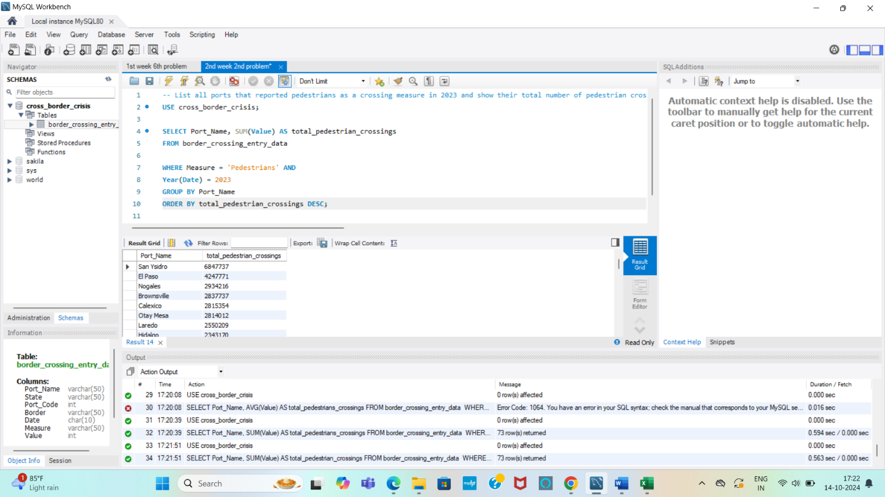

**DESCRIPTION:**

1. WHERE Measure = 'Pedestrians' AND Year(Date) = 2023: Filters the data for pedestrian crossings in 2023.
2. SUM(Value): Calculates the total pedestrian crossings for each port.
3. GROUP BY Port_Name: Groups the data by port.
4. ORDER BY total_pedestrian_crossings DESC: Sorts the ports by total crossings, with the highest numbers first.

**- - - - - - - - - - - - - - - - - - - - - - - - - - - - - - - - - - - - - - - - - - - - - - - - - - - - - - - - - - - - - - - - - - - - - - - - - - - - - - - - - -**

**6. Extract the total number of crossings in each border for every year available in the dataset.**

**QUERY:**

**SELECT** Border, Year(Date) **AS** Year, **SUM**(Value) **AS** total_crossings

**FROM** border_crossing_entry_data

**GROUP BY** Border, Year(Date)

**ORDER BY** Border, Year;

**OUTPUT:**

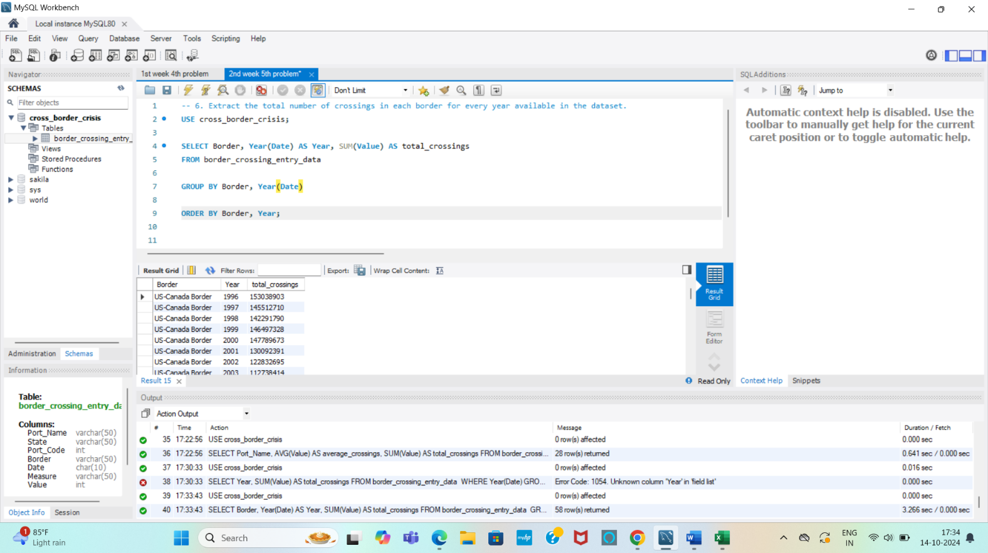

**DESCRIPTION:**

1. SUM(Value): Computes total crossings per border per year.
2. GROUP BY: Groups data by border and year.
3. ORDER BY: Sorts the output by border and then by year.

**- - - - - - - - - - - - - - - - - - - - - - - - - - - - - - - - - - - - - - - - - - - - - - - - - - - - - - - - - - - - - - - - - - - - - - - - - - - - - - - - -**

**7. Identify the month in 2023 with the highest number of truck crossings. List the month and total truck crossings.**

**QUERY:**

**SELECT DATE_FORMAT**(Date, '%Y-%m') **AS** Month**, SUM**(Value) **AS** total_truck_crossings

**FROM** border_crossing_entry_data

**WHERE** YEAR(Date) = 2023 **AND** Measure = 'Trucks'

**GROUP BY DATE_FORMAT**(Date, '%Y-%m')

**ORDER BY** total_truck_crossings **DESC**

**LIMIT** 1;

**OUTPUT:**

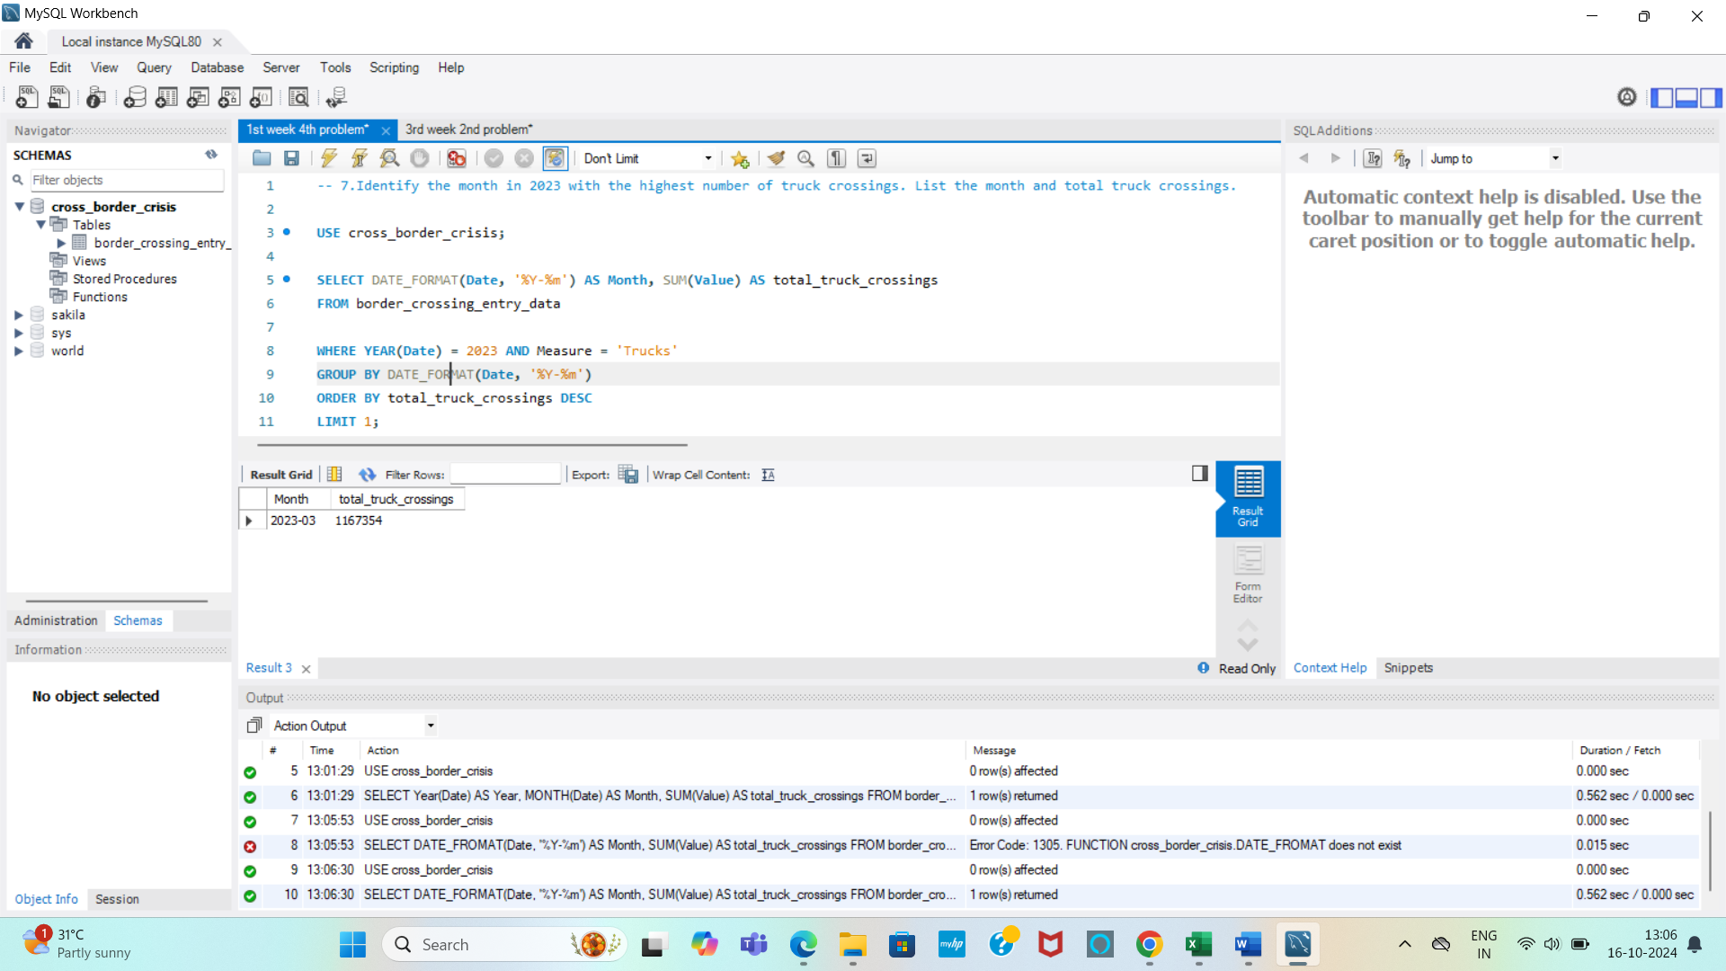

**DESCRIPTION:**

1. DATE_FORMAT(date, '%Y-%m') formats the date to extract the year and month in YYYY-MM format.
2. The WHERE clause filters the data to only include records from the year 2023 and where the measure is for trucks.
3. SUM(value) calculates the total number of truck crossings for each month.
4. The results are ordered by the total truck crossings in descending order to find the month with the highest value.
5. LIMIT 1 ensures that only the month with the highest number of truck crossings is returned.

**- - - - - - - - - - - - - - - - - - - - - - - - - - - - - - - - - - - - - - - - - - - - - - - - - - - - - - - - - - - - - - - - - - - - - - - - - - - - - - - - - -**

**8. List the top 5 ports with the highest crossing activity (all measure types) in 2021, showing the measure type and total crossings for each port.**

**QUERY:**

**SELECT** Port_Name, Measure, **SUM**(Value) **AS** total_crossings

**FROM** border_crossing_entry_data

**WHERE** YEAR(Date) = 2021

**GROUP BY** Port_Name, Measure

**ORDER BY** total_crossings DESC

**LIMIT** 5;

**OUTPUT**:

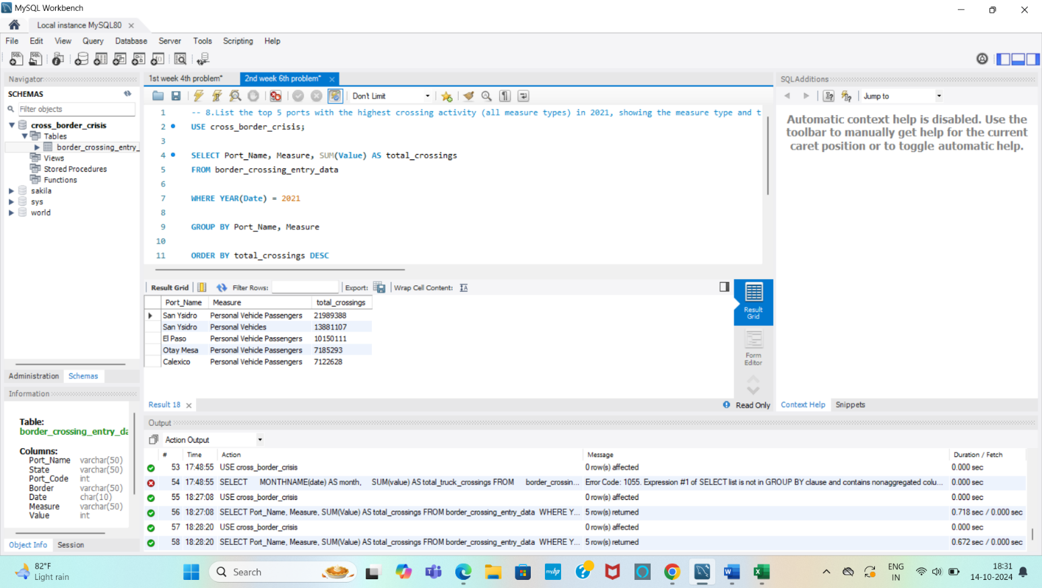

**DESCRIPTION:**

1. SUM(value) AS total_crossings: Calculates the total number of crossings for each port and measure type.
2. WHERE YEAR(date) = 2021: Filters the data to include only entries from the year 2021.
3. GROUP BY port_name, measure: Groups the results by each port and measure type.
4. ORDER BY total_crossings DESC: Sorts the results in descending order based on the total number of crossings.
5. LIMIT 5: Returns the top 5 ports with the highest crossing activity.

**- - - - - - - - - - - - - - - - - - - - - - - - - - - - - - - - - - - - - - - - - - - - - - - - - - - - - - - - - - - - - - - - - - - - - - - - - - - - - - - - - -**

**WEEK 3: Advanced Queries and Research-Like Tasks**

**1. Calculate the total number of crossings for each year from 2019 to 2023, grouped by border and measure type.**

**QUERY:**

**SELECT** YEAR(Date) AS year, Border, Measure, **SUM**(Value) **AS** total_crossings

**FROM** border_crossing_entry_data

**WHERE** YEAR(Date) **BETWEEN** 2019 **AND** 2023

**GROUP BY** year,Border, Measure

**ORDER BY** year, Border, Measure

**OUTPUT:**

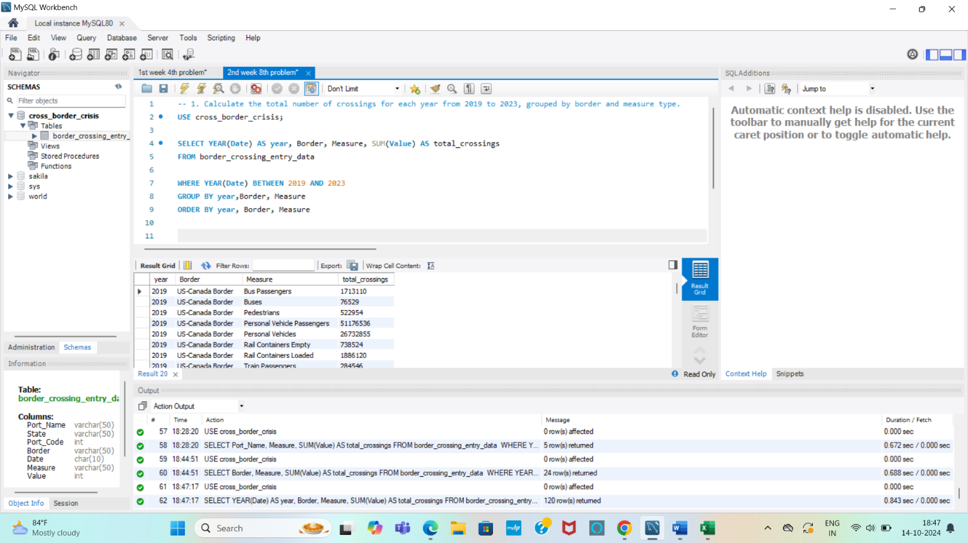

**DESCRIPTION:**

1. YEAR(date) AS year: Extracts the year from the date column.
2. SUM(value) AS total_crossings: Calculates the total number of crossings for each combination of year, border, and measure type.
3. WHERE YEAR(date) BETWEEN 2019 AND 2023: Filters the data to include only the years from 2019 to 2023.
4. GROUP BY year, border, measure: Groups the results by year, border, and measure type.
5. ORDER BY year, border, measure: Sorts the results by year, then by border, and finally by measure type.

**- - - - - - - - - - - - - - - - - - - - - - - - - - - - - - - - - - - - - - - - - - - - - - - - - - - - - - - - - - - - - - - - - - - - - - - - - - - - - - - - - -**

**2. For Texas, find the most frequently recorded measure types for 2023. Rank the measure types by the number of entries without using RANK().**

Since you can't use the RANK() function, we'll use COUNT() and ORDER BY to achieve the ranking.

**QUERY:**

**SELECT** Measure, **COUNT**(*) **AS** entry_count **FROM** border_crossing_entry_data

**WHERE** State = 'Texas' **AND** YEAR(Date) = 2023

**GROUP BY** Measure

**ORDER BY** entry_count **DESC**;

**OUTPUT:**

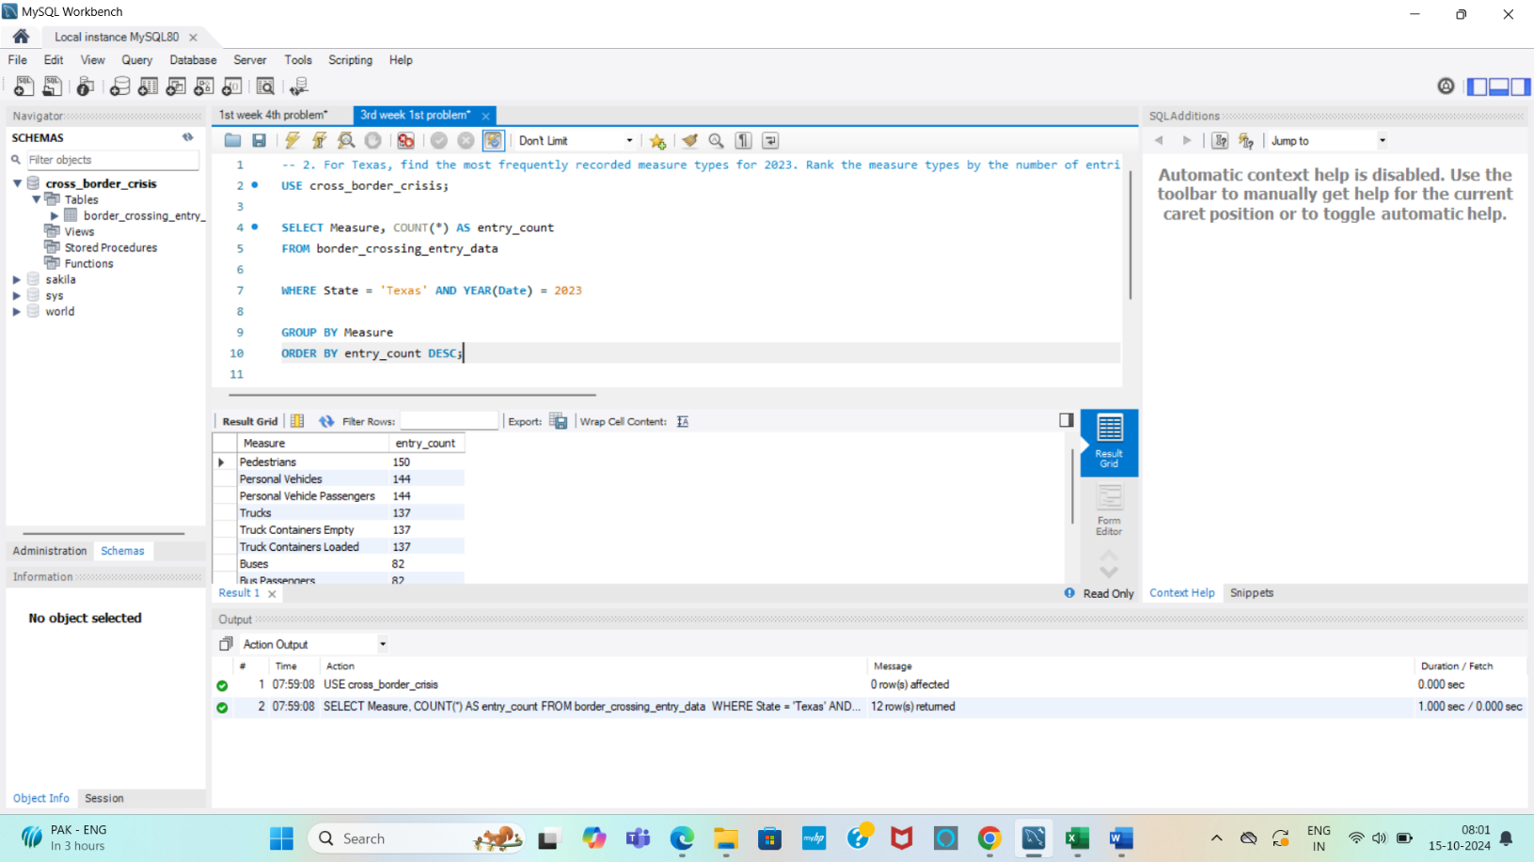

**DESCRIPTION:**

* COUNT(*) calculates the number of entries for each measure.
* GROUP BY measure groups the results by each measure type.
* ORD+ER BY entry_count DESC sorts the measure types in descending order based on the number of entries, giving you the most frequently recorded measure types at the top.

**- - - - - - - - - - - - - - - - - - - - - - - - - - - - - - - - - - - - - - - - - - - - - - - - - - - - - - - - - - - - - - - - - - - - - - - - - - - - - - - - - -**

**3. Compare the total number of container crossings over the last 3 years for each border.**

**QUERY:**

**SELECT** Border, YEAR(Date) **AS** Year, **SUM**(Value) **AS** total_container_crossings

**FROM** border_crossing_entry_data

**WHERE** Measure **LIKE** '% Containers %' **AND** YEAR(Date) **BETWEEN** YEAR(CURDATE()) - 2 **AND** YEAR(CURDATE()) - 0

**GROUP BY** Border, YEAR(Date)

**ORDER BY** Border, Year;

**OUTPUT:**

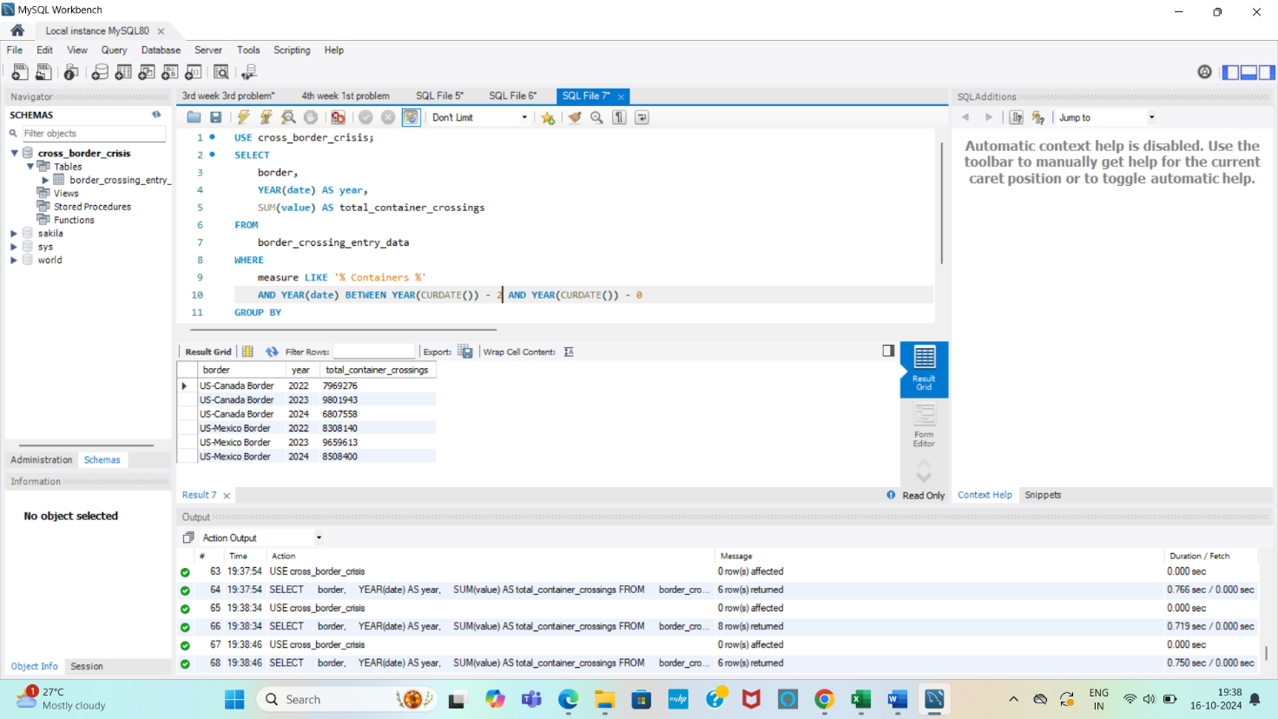

**DESCRIPTION:**

1. YEAR(date) extracts the year from the date.
2. The WHERE clause filters the data to include only records where the measure is 'Containers' and limits the years to the last three years.
3. SUM(value) calculates the total number of container crossings for each year and border.
4. The results are grouped by border and year to display totals for each combination.
5. The results are ordered by border and then by year to make the comparison clear.

**- - - - - - - - - - - - - - - - - - - - - - - - - - - - - - - - - - - - - - - - - - - - - - - - - - - - - - - - - - - - - - - - - - - - - - - - - - - - - - - - - -**

**4. Identify the busiest month of each year (2020-2023) in terms of pedestrian crossings. Show the year, month, and total pedestrian crossings**

**QUERY:**

**WITH** PedestriansMonthlyTotal **AS** (

**SELECT** YEAR(Date) **AS** year, MONTH(Date) **AS** month, **SUM**(Value) **AS** total_pedestrian_crossings

**FROM** border_crossing_entry_data

**WHERE** Measure = 'Pedestrians' **AND** YEAR(Date) **BETWEEN** 2020 **AND** 2023

**GROUP BY** YEAR(Date), MONTH(Date))

**SELECT** year, month, total_pedestrian_crossings **FROM** PedestriansMonthlyTotal

**WHERE** total_pedestrian_crossings = (

**SELECT MAX**(total_pedestrian_crossings)

**FROM** PedestriansMonthlyTotal **AS** subquery

**WHERE** subquery.year = PedestriansMonthlyTotal.year)

**ORDER BY** year, month;

**OUTPUT:**

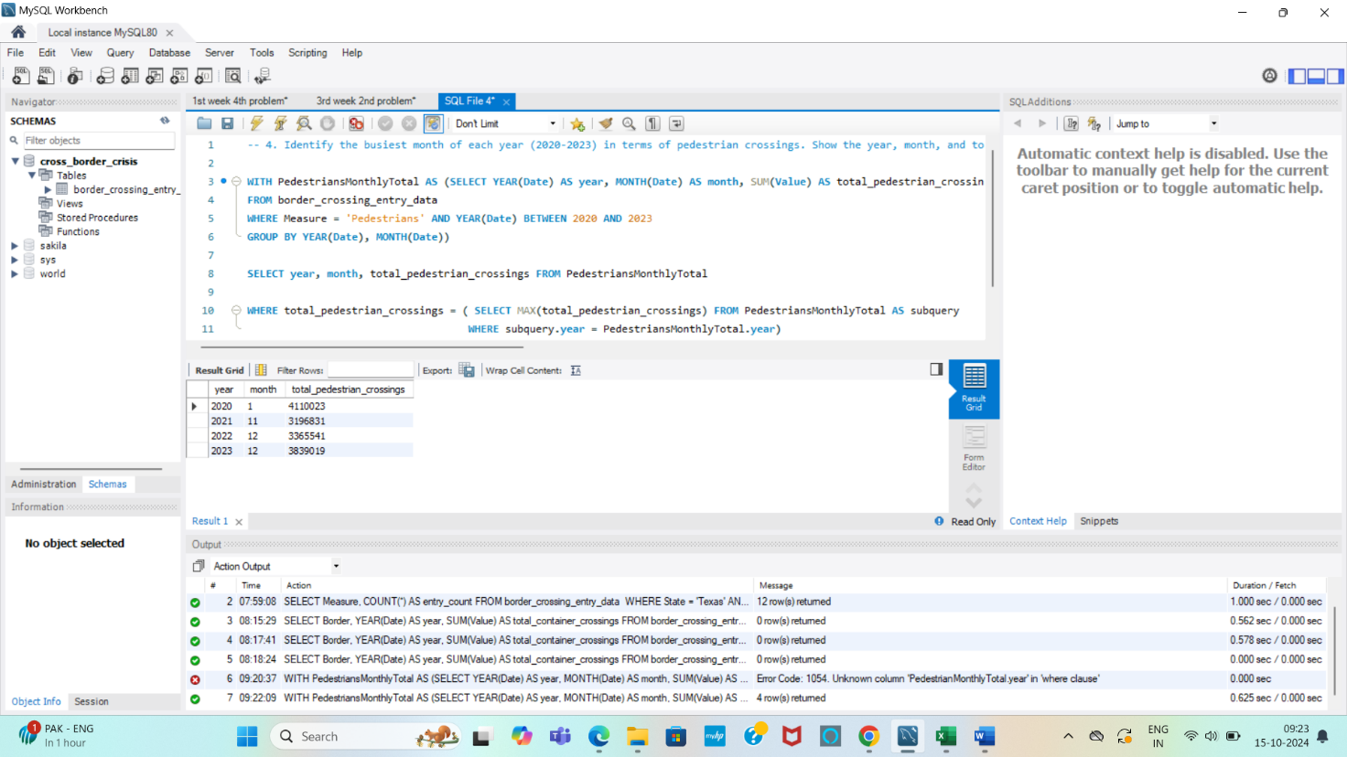

**DESCRIPTION:**

1. **Common Table Expression (CTE)**: We use a CTE named PedestrianMonthlyTotals to calculate the total pedestrian crossings for each month of each year.
2. SUM(value) calculates the total pedestrian crossings for each month.
3. **Filtering**: The WHERE measure = 'Pedestrians' clause ensures that only pedestrian crossing data is included.
4. **Finding the Busiest Month**: The main query selects the busiest month for each year using a subquery to get the maximum monthly crossings for each year.
5. The results are ordered by year and month.

**- - - - - - - - - - - - - - - - - - - - - - - - - - - - - - - - - - - - - - - - - - - - - - - - - - - - - - - - - - - - - - - - - - - - - - - - - - - - - - - - - -**

**5. Compare the total number of truck crossings in 2021 and 2022 at the top 5 busiest ports for trucks. Display both years' totals side by side.**

**QUERY:**

**WITH** TruckCrossings **AS** (

**SELECT** Port_Name, YEAR(Date) **AS** year, **SUM**(Value) **AS** total_truck_crossings

**FROM** border_crossing_entry_data

**WHERE** Measure = 'Trucks' **AND** YEAR(Date) **IN** (2021, 2022)

**GROUP BY** Port_Name, YEAR(Date)),

Top5Ports **AS** (

**SELECT** Port_Name, **SUM**(total_truck_crossings) **AS** total_crossings

**FROM** TruckCrossings

**GROUP BY** Port_Name

**ORDER BY** total_crossings **DESC**

**LIMIT** 5)

**SELECT** t.Port_Name,

**SUM**(**CASE WHEN** t.year = 2021 **THEN** t.total_truck_crossings **ELSE 0 END**) **AS** total_truck_crossings_2021,

**SUM**(**CASE** **WHEN** t.year = 2022 **THE**N t.total_truck_crossings **ELSE 0 END**) **AS** total_truck_crossings_2022

**FROM** TruckCrossings t

**JOIN** Top5Ports tp **ON** t.Port_Name=tp.Port_Name

**GROUP BY** t.Port_Name

**ORDER BY** total_truck_crossings_2021 + total_truck_crossings_2022 **DESC**;

**OUTPUT:**

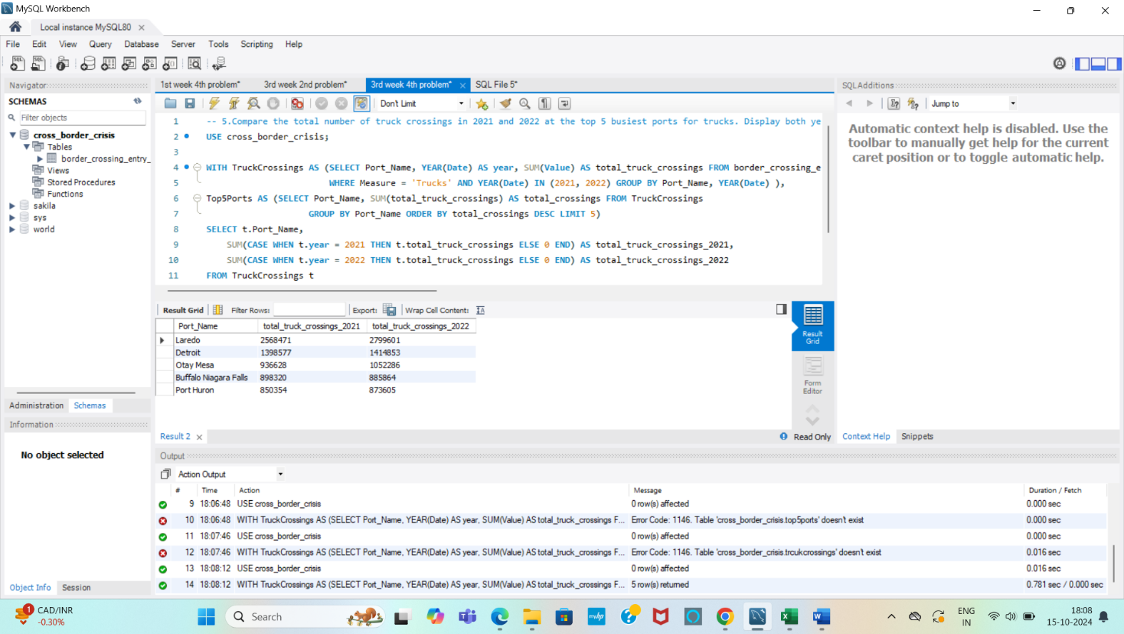

**DESCRIPTION:**

1. TruckCrossings CTE: This common table expression calculates the total number of truck crossings for each port for the years 2021 and 2022.
2. Top5Ports CTE: This CTE identifies the top 5 ports with the highest total truck crossings across both years.
3. The main query joins the TruckCrossings data with the Top5Ports to display only the data for the busiest ports.
4. The CASE statements in the main query help to display the total truck crossings for 2021 and 2022 side by side.
5. The results are ordered by the combined total truck crossings for both years, showing the busiest ports at the top.

**- - - - - - - - - - - - - - - - - - - - - - - - - - - - - - - - - - - - - - - - - - - - - - - - - - - - - - - - - - - - - - - - - - - - - - - - - - - - - - - - - -**

**6. Find the port with the lowest total crossings on the U.S.-Canada border for any measure type in 2023.**

**QUERY:**

**SELECT** Port_Name, Measure, **SUM**(Value) **AS** lowest_total_crossings

**FROM** border_crossing_entry_data

**WHERE** Border = 'US-Canada Border' **AND** YEAR(Date) = 2023

**GROUP BY** Port_Name, Measure

**ORDER BY** lowest_total_crossings **ASC**

**LIMIT** 1;

**OUTPUT:**

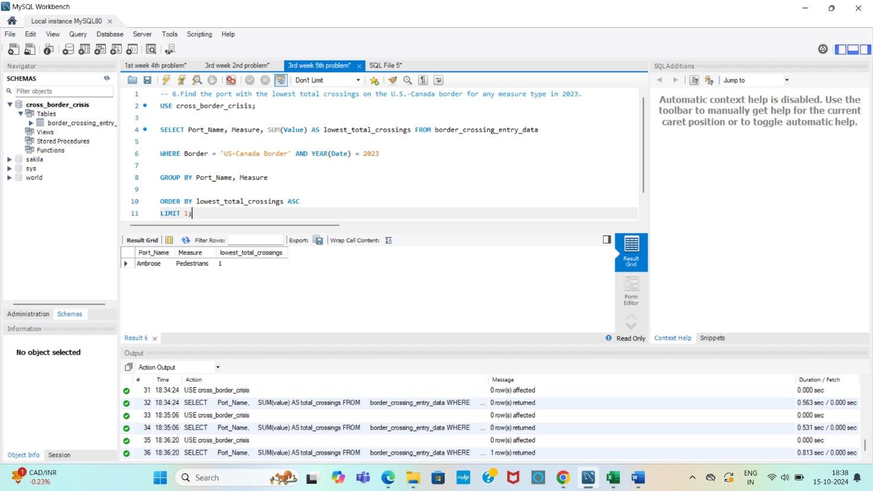

**DESCRIPTION:**

* SUM(value) calculates the total number of crossings for each port.
* WHERE border = 'U.S.-Canada' AND YEAR(date) = 2023 filters the data to include only crossings on the U.S.-Canada border in 2023.
* GROUP BY port_name groups the results by port.
* ORDER BY total_crossings ASC sorts the ports in ascending order based on the number of crossings.
* LIMIT 1 ensures that only the port with the lowest total crossings is returned.

**- - - - - - - - - - - - - - - - - - - - - - - - - - - - - - - - - - - - - - - - - - - - - - - - - - - - - - - - - - - - - - - - - - - - - - - - - - - - - - - - - -**

**7. List the monthly total number of crossings for buses across all states in 2022, sorted in ascending order.**

**QUERY:**

**SELECT** YEAR(Date) **AS** Year, MONTH(Date) **AS** Month, **SUM**(Value) **AS** total_bus_crossings

**FROM** border_crossing_entry_data

**WHERE** Measure = 'Buses' **AND** YEAR(Date) = 2022

**GROUP BY** YEAR(Date), MONTH(Date)

**ORDER BY** total_bus_crossings **ASC**;

**OUTPUT:**

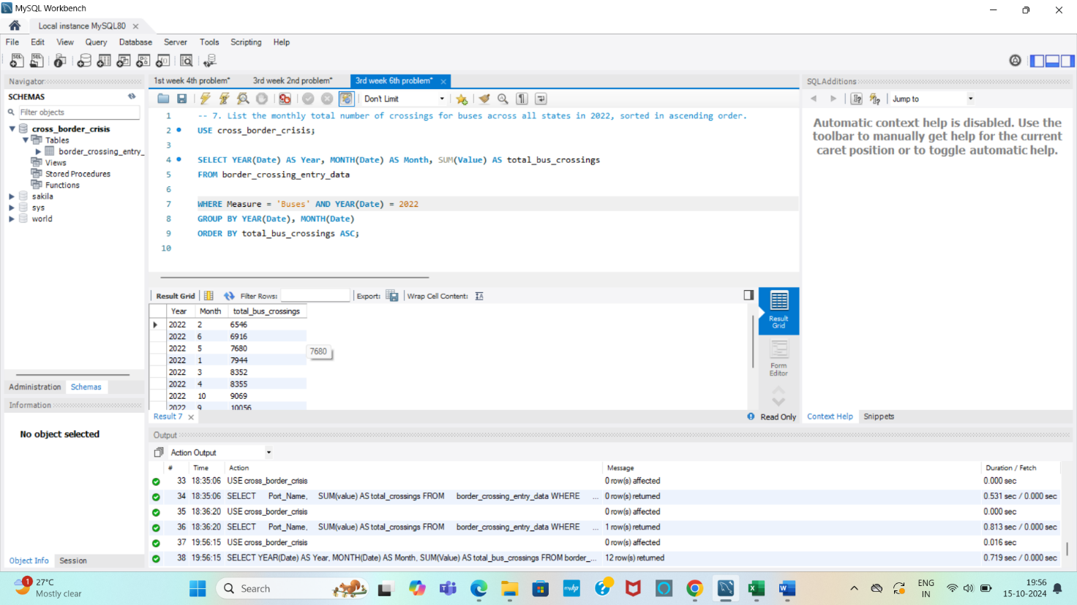

**DESCRIPTION:**

* SUM(value) calculates the total number of bus crossings for each month.
* WHERE measure = 'Buses' AND YEAR(date) = 2022 filters the data to include only bus crossings in the year 2022.
* GROUP BY YEAR(date), MONTH(date) groups the results by month.
* ORDER BY total_bus_crossings ASC sorts the monthly totals in ascending order, showing the months with the fewest bus crossings first.

**- - - - - - - - - - - - - - - - - - - - - - - - - - - - - - - - - - - - - - - - - - - - - - - - - - - - - - - - - - - - - - - - - - - - - - - - - - - - - - - - - -**

**8. Display the sum and average number of crossings for each state, grouped by measure type and year. Only show entries where the average crossings exceed 500.**

**QUERY:**

**SELECT** State, Measure, YEAR(Date) **AS** Year, SUM(Value) **AS** total_crossings, **AVG**(Value) **AS** average_crossings

**FROM** border_crossing_entry_data

**GROUP BY** State, Measure, YEAR(Date)

**HAVING AVG**(Value) > 500

**ORDER BY** State, Measure, Year;

**OUTPUT:**

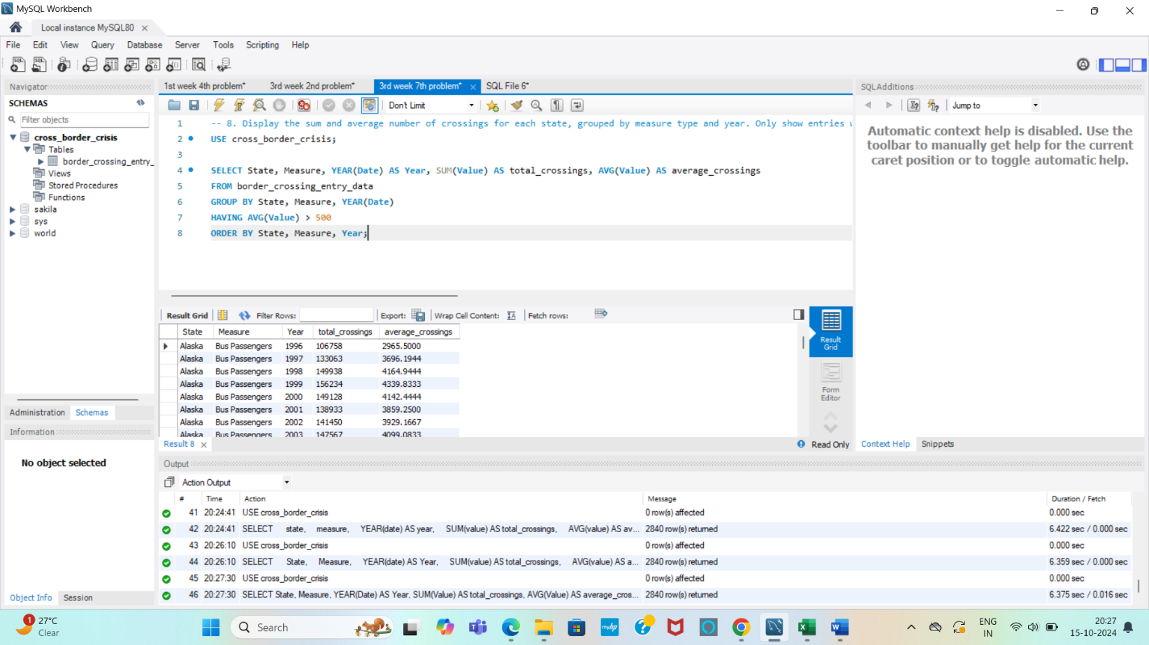

**DESCRIPTION:**

* SUM(value) calculates the total number of crossings for each state, measure type, and year.
* AVG(value) calculates the average number of crossings for each state, measure type, and year.
* GROUP BY state, measure, YEAR(date) groups the results by state, measure, and year.
* HAVING AVG(value) > 500 filters the groups to include only those where the average number of crossings exceeds 500.
* ORDER BY state, measure, year sorts the results for easier readability.

**- - - - - - - - - - - - - - - - - - - - - - - - - - - - - - - - - - - - - - - - - - - - - - - - - - - - - - - - - - - - - - - - - - - - - - - - - - - - - - - - - -**

**Key Findings and Insights from the dataset, such as**

**The busiest ports and states for crossings.**

Top busiest ports and states for crossings are San Ysidro -California, El Paso -Texas, Laredo-Texas, Hidalgo -Texas, Calexico-California, Buffalo Nagar falls-New York, Brownsville-Texas, Otay Mesa-California.

**Patterns and trends by border (U.S.-Mexico vs U.S.-Canada) and How the number of crossings varies by measure type, year, and month**

**Measure Type Patterns**: Understanding which crossing types are dominant helps align border resources with actual traffic, supporting better service delivery. From the dataset, there are higher in personal vehicle passengers, personal vehicle and trucks that cross US-Canada and US- Mexico borders.

**Peak Crossing Months**: Identifying high-traffic months for each border aids in seasonal workforce planning and infrastructure utilization. By analysing the dataset, I found the peak crossing months are March, May and December.

**Peak Crossing Months**: Identifying high-traffic months for each border aids in seasonal workforce planning and infrastructure utilization.